D. Vishnu Vardhan Reddy
Donapativishnu21@gmail.com
TASK 1 & 2
- STUDENT MANAGEMENT SYSTEM DATABASE
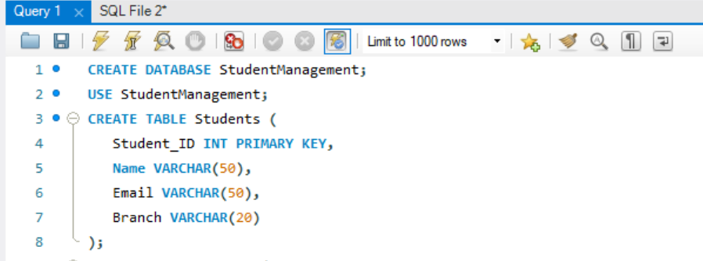

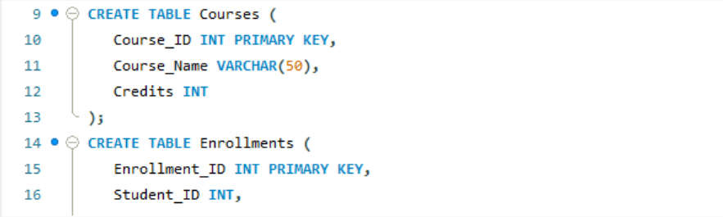

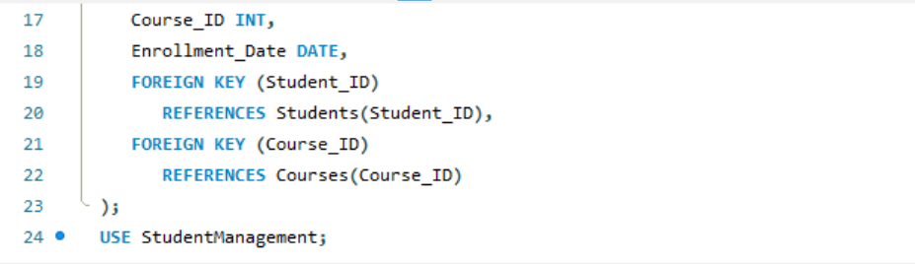

Primary Keys
Primary Keys are used to uniquely identify each record in a table.
Every table contains one primary key to avoid duplicate records.
- student_id → Primary key of the Students table
- course_id → Primary key of the Courses table
- enrollment_id → Primary key of the Enrollments table

Foreign Keys
Foreign Keys are used to create relationships between tables and maintain data integrity.
- student_id in the Enrollments table references the Students table
- course_id in the Enrollments table references the Courses table
These keys connect students with the courses they enroll in.

Students Table Structure
Column Name | Data Type | Description
Student_ID | INT | Used to store the unique ID of each student
Name | VARCHAR(50) | Stores the name of the student
Email | VARCHAR(50) | Stores the email address of the student
Branch | VARCHAR(20) | Stores the department or branch of the student

Courses Table Structure
Column Name | Data Type | Description
Course_ID | INT | Stores the unique course identifier
Course_Name | VARCHAR(50) | Stores the name of the course
Credits | INT | Represents the credit value of the course

Enrollments Table Structure
Column Name | Data Type | Description
Enrollment_ID | INT | Stores the unique enrollment record ID
Student_ID | INT | Refers to the student who enrolled
Course_ID | INT | Refers to the selected course
Enrollment_Date | DATE | Stores the date of enrollment

OUTPUT :
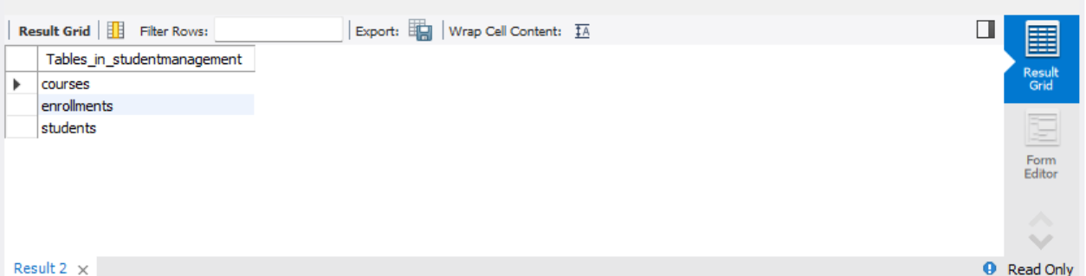

TASK 3

Database Relationships

One-to-Many Relationship (1:M)
In this type of relationship, a single record in one table can be associated with multiple records in another table. However, each record in the second table belongs to only one record in the first table.

Example:
A single teacher can teach many students, but each student is assigned to only one teacher.

One-to-One Relationship (1:1)
In a one-to-one relationship, one record in a table is connected to exactly one record in another table.

Example:
One user can have only one passport, and each passport belongs to only one user.

Many-to-Many Relationship (M:N)
In this relationship, multiple records from one table can be connected to multiple records in another table.

Example:
A student can join several courses, and a course can contain many students.
This type of relationship is usually managed using an intermediate table such as an Enrollment table.
.

TASK 4
REAL-WORLD DATABASE SCHEMA
ONLINE SHOPPING
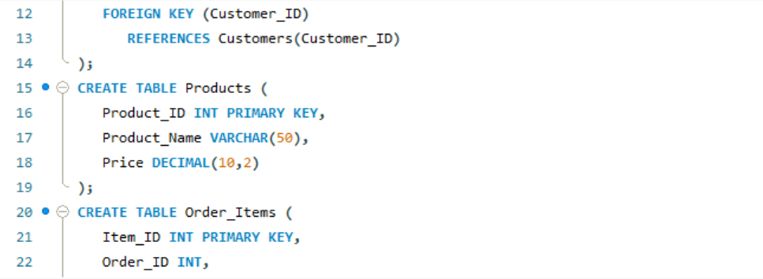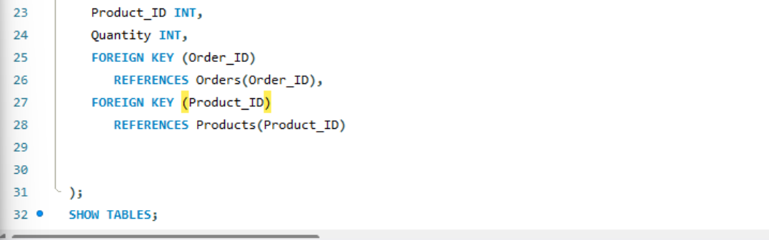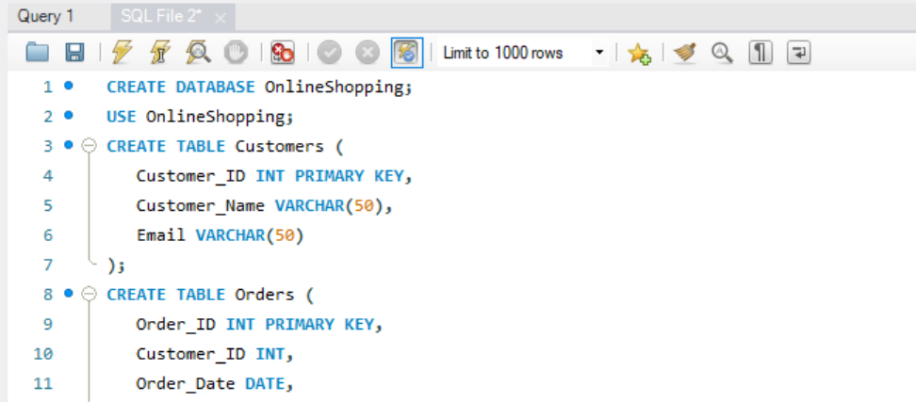

OUTPUT:
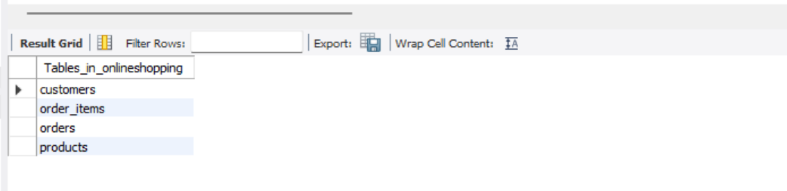

Tables Created

1. Customers
This table stores all customer-related information such as customer ID, name, email, phone number, and address.
Each customer is uniquely identified using Customer_ID.

2. Orders
The Orders table keeps track of all orders placed by customers.
It stores details like order ID, order date, payment status, and the customer who placed the order.

3. Products
This table contains information about the products available in the shopping system.
It includes product ID, product name, price, quantity, and stock details.

4. Order_Items
The Order_Items table acts as a linking table between Orders and Products.
It stores which products are included in a particular order along with the quantity purchased.

Relationships Used
Relationship | Description | Type
Customers → Orders | One customer can place multiple orders | One-to-Many
Orders → Order_Items | One order can contain many items/products | One-to-Many
Products → Order_Items | One product can appear in multiple order items | One-to-Many

Keys Used

Primary Keys
Primary Keys are used to uniquely identify each record in a table.
- Customer_ID → Unique identifier for customers
- Order_ID → Unique identifier for orders
- Product_ID → Unique identifier for products
- Item_ID → Unique identifier for order items

